# Portfolio Report

Alice Roherty-Carrier

January 19th, 2020

Sites I Like:

* [Findmatthew.com](http://findmatthew.com/)
* Ejosue.com
* Caferati.me

Sites I Don’t Like:

* [Chippd.github.io](http://findmatthew.com/)
* Ybrikman.com
* Jtom.me

What I Like About Findmatthew.com:

* [I](http://findmatthew.com/) like that it has a landing page
* I like that the UI elements are animated into the page when scrolling
* I like how the navigation bar is underneath the landing page but snaps to the top once you scroll below it.
* I like the pink and green accents on the navbar.
* I like that the arrow inside the button rotates when you hover over the button.

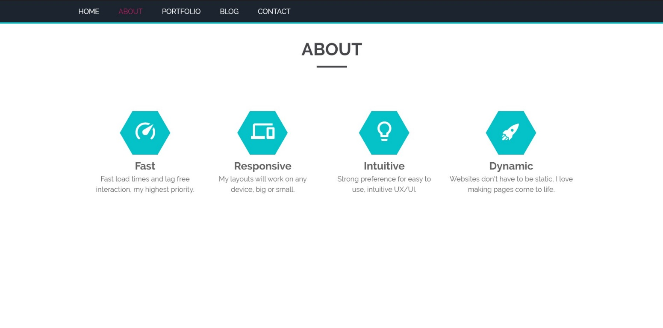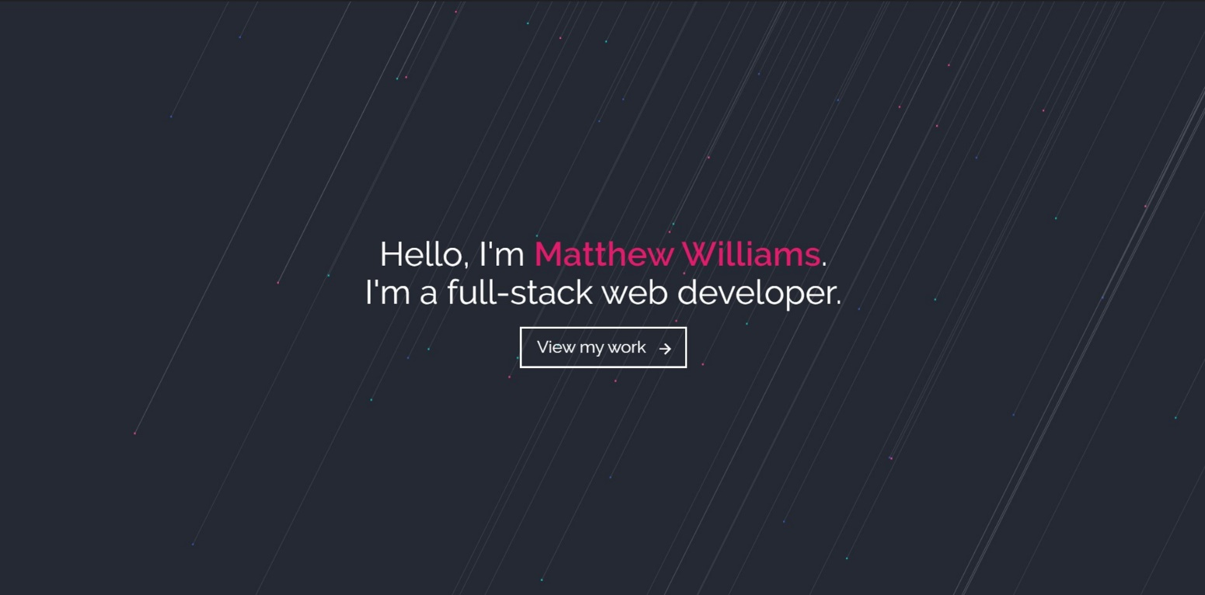

What I Like About Ejosue.com:

* [I](http://findmatthew.com/) like the animated landing page.
* I like the animated icons
* I like the transition when leaving the landing page.

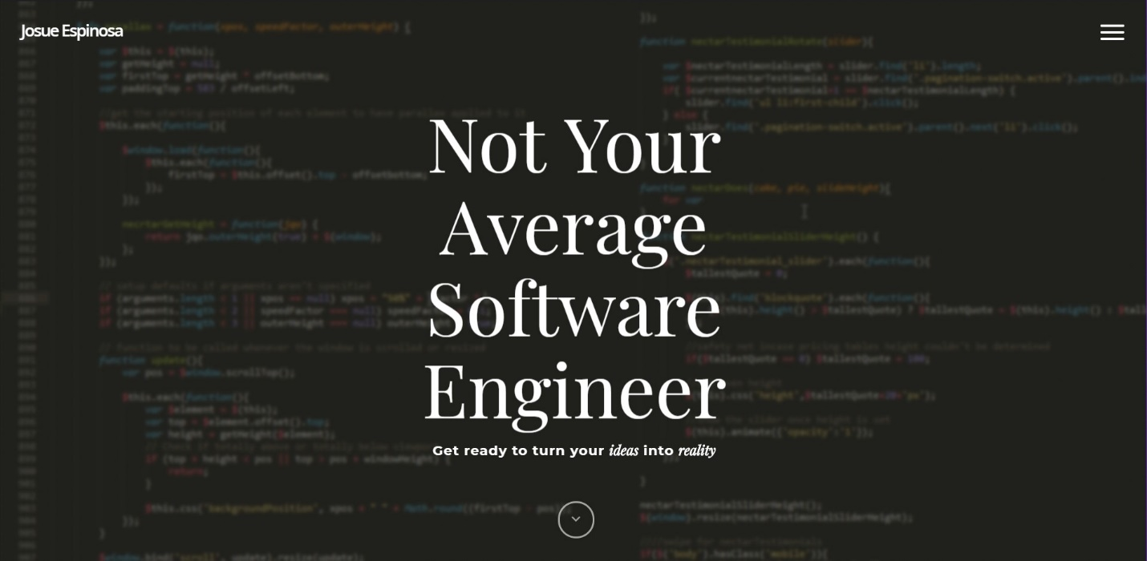

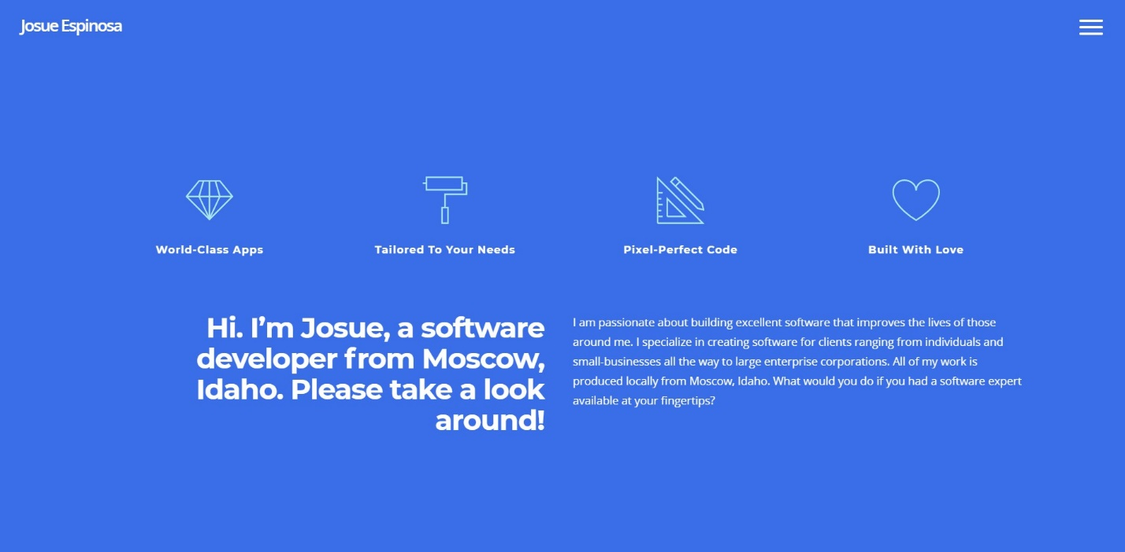

What I Like About Caferati.me:

* [I](http://findmatthew.com/) like the animations on the landing page particularly the animations on the text.
* I like the animations on the hamburger menu icon.
* I like the page transitions.

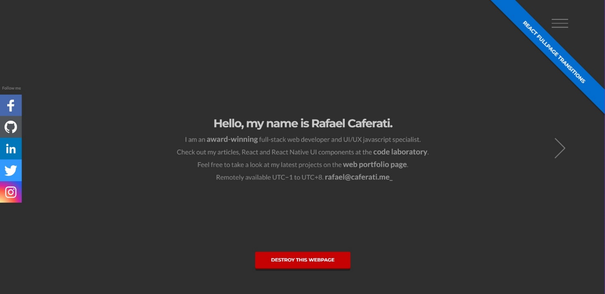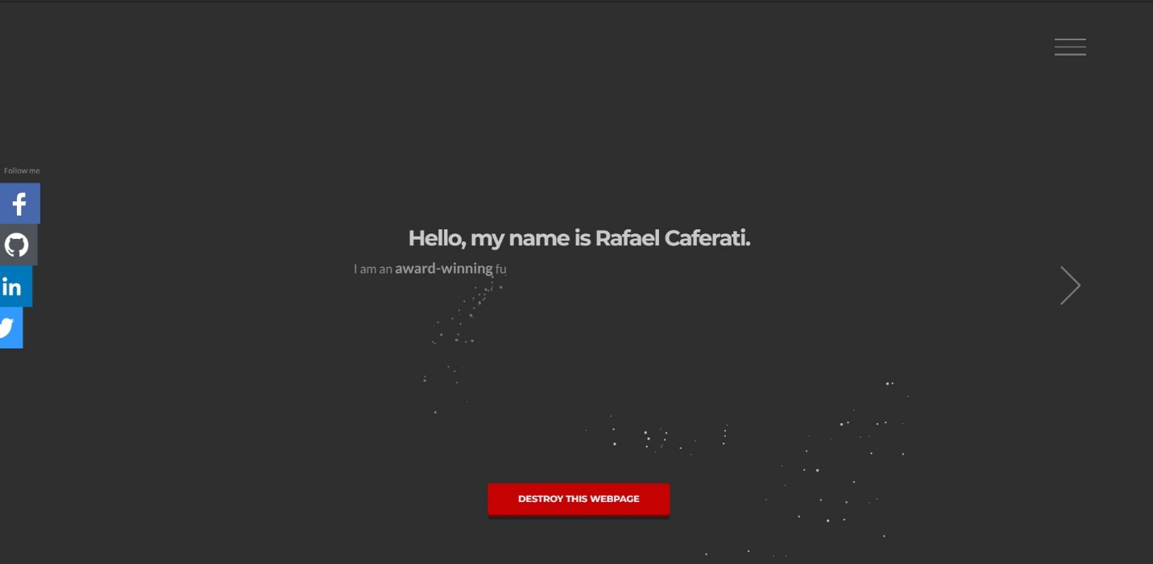

What I Don’t Like About Chippd.github.io:

* [I](http://findmatthew.com/) don’t like that it lacks a proper landing page.
* I don’t like that the page has no movement (animations)
* I don’t like how repetitive the page seems as you scroll down.
* The URL isn’t very memorable.

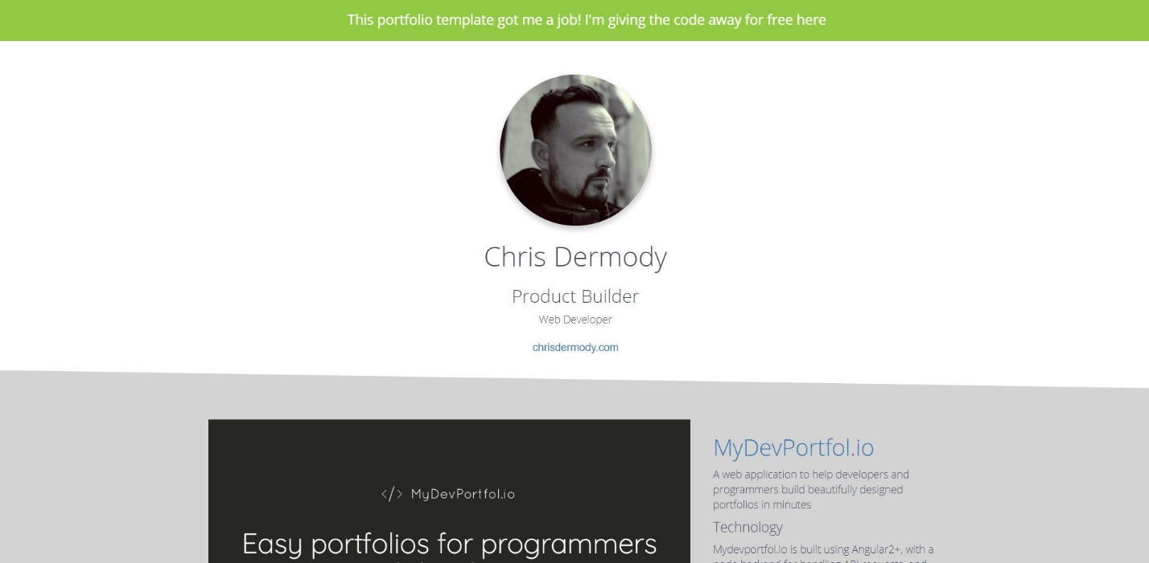

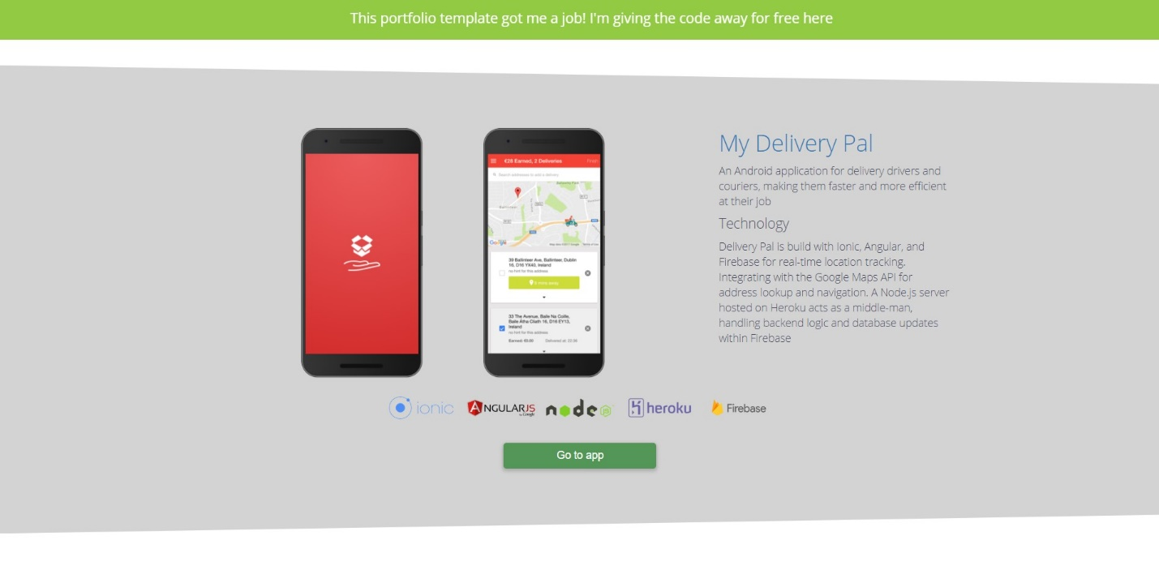

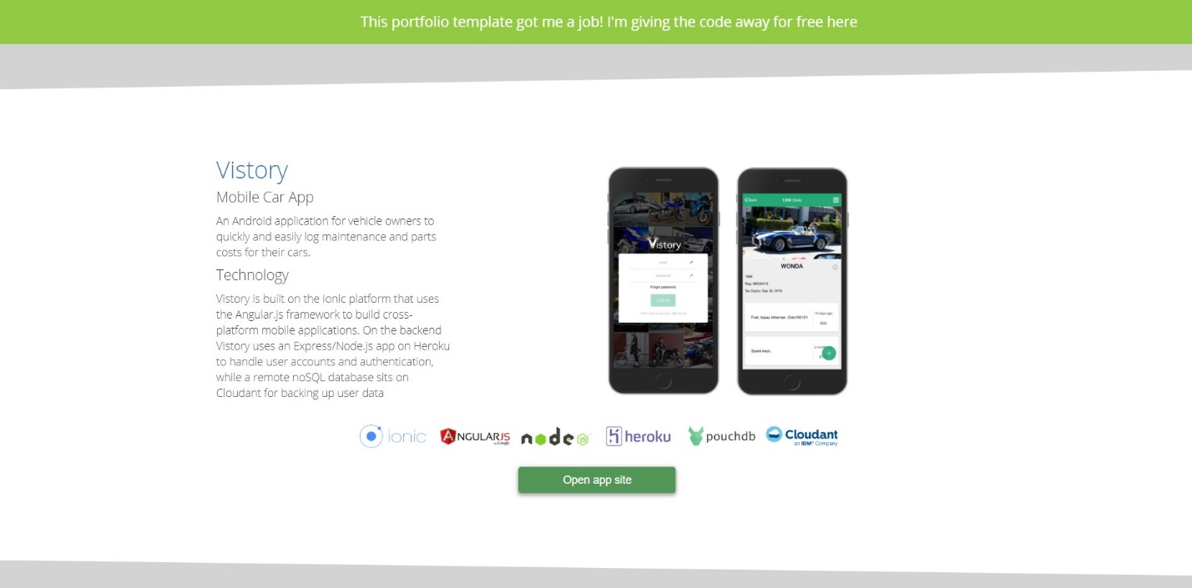

What I Don’t Like About Ybrikman.com:

* [I](http://findmatthew.com/) don’t like how plain it looks.
* I don’t like that it mainly consists of black and white.
* The hamburger menu doesn’t show up at the right screen size.

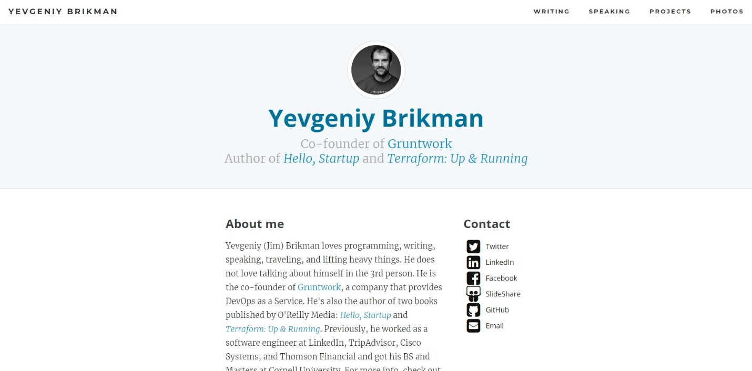

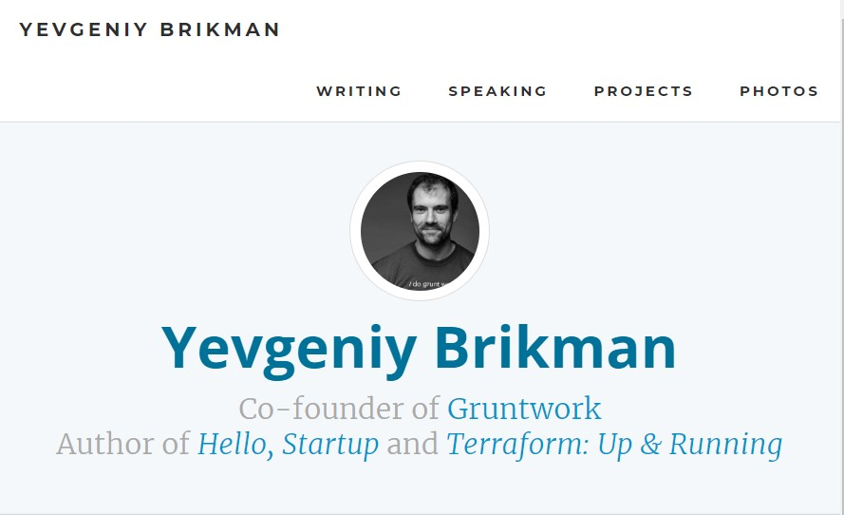

What I Don’t Like About Jtom.me:

* [I](http://findmatthew.com/) don’t like the overall theme, I think it looks like a MS Word template that was turned into a website.
* I don’t like that when I hover over links in the navbar they all shift position.
* I don’t like how much of the screen is taken up by the navbar. (It takes up half the screen on mobile)

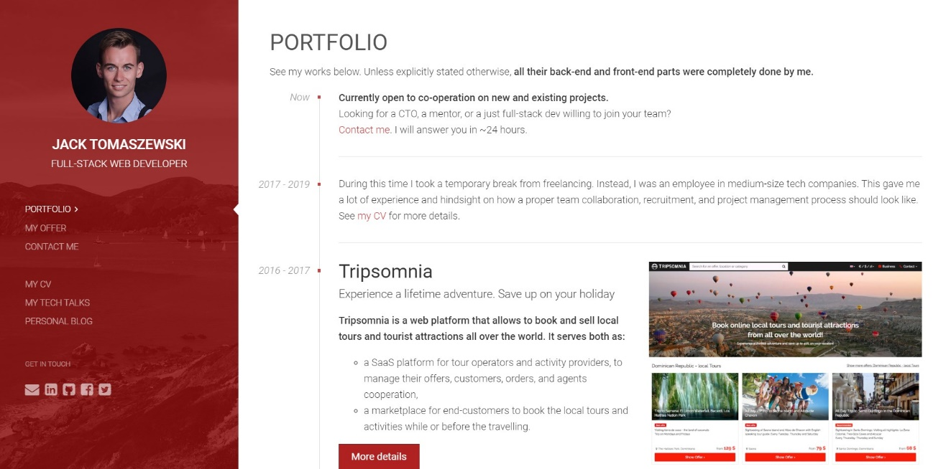

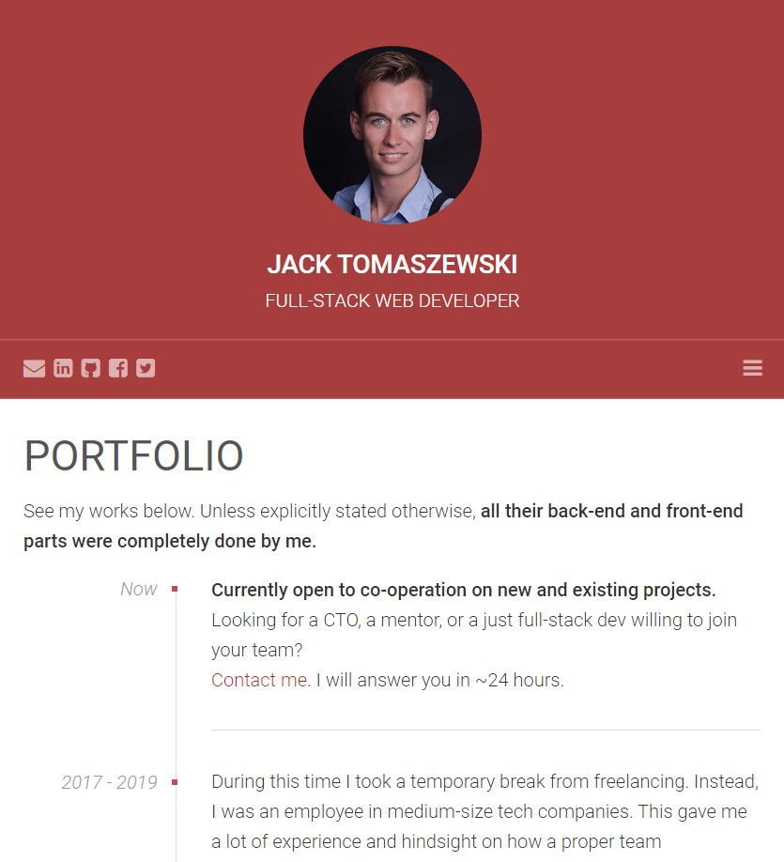

My Portfolio Plans

Written Description:

I plan for my portfolio to have a full screen landing page like findmatthew.com or caferati.me. I hope to be able to use particles.js for the landing page to add a bit of movement to the landing page. I also hope to use animate.css or anime.js to allow the elements to load into the landing page in an appealing manner as well as general animations as I see fit.

My website will contain pages titled: About, Resume, Portfolio, Contact, and Blog. I hope to have everything on a single page with elements being animated into the page as the user scrolls down. For creating this type of layout I would like to use fullPage.js

Wireframes:

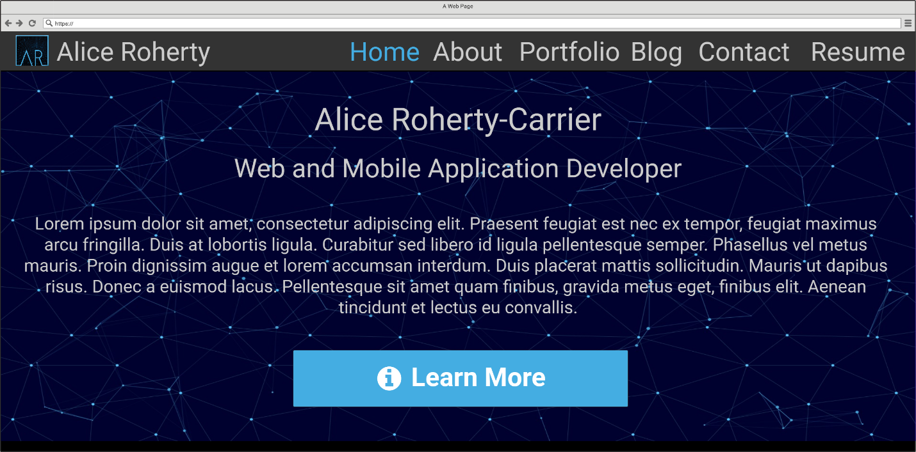

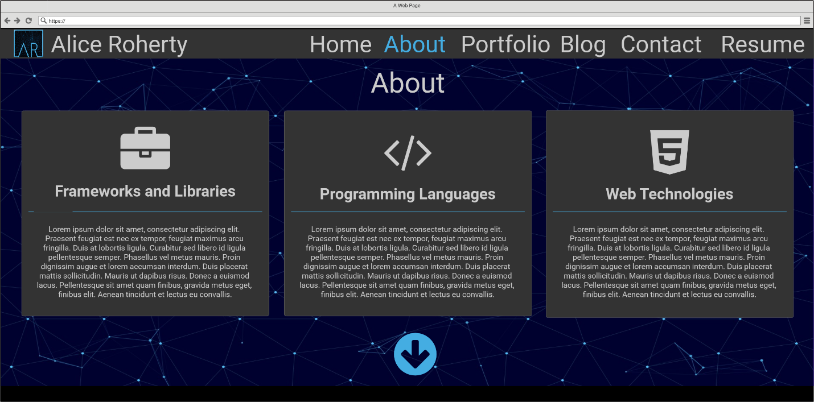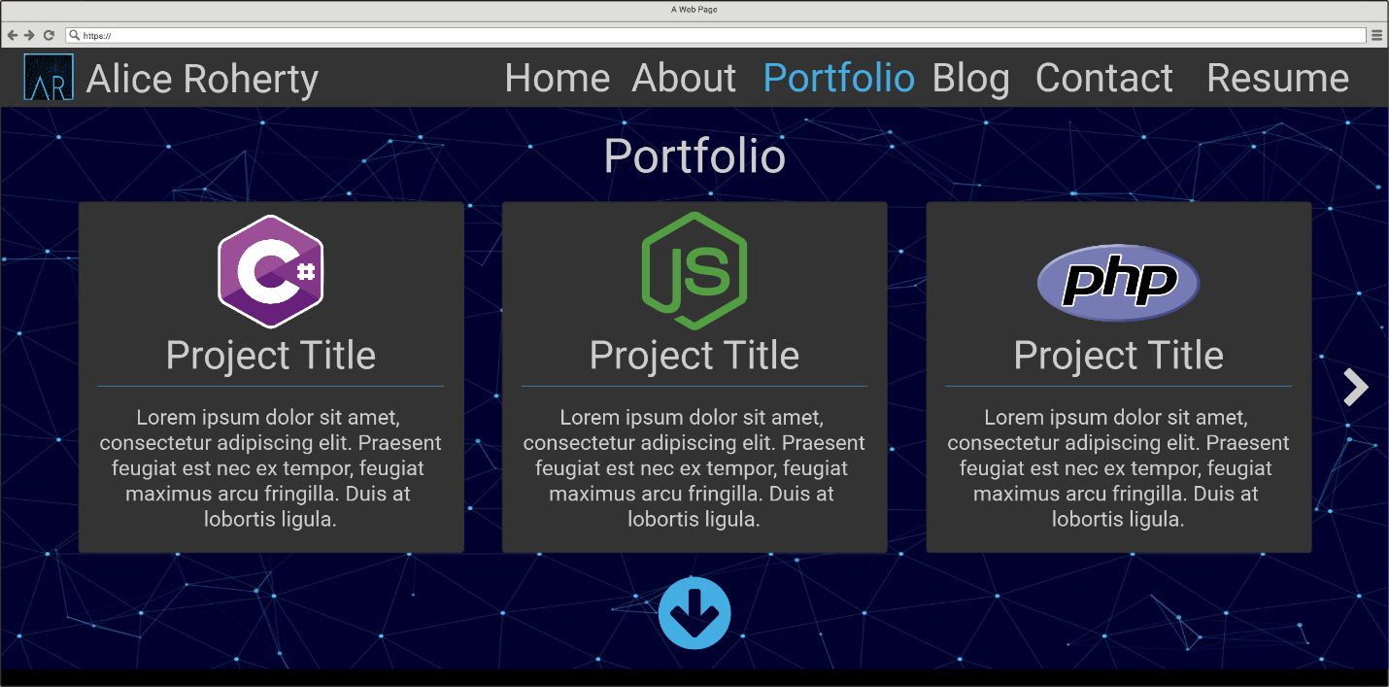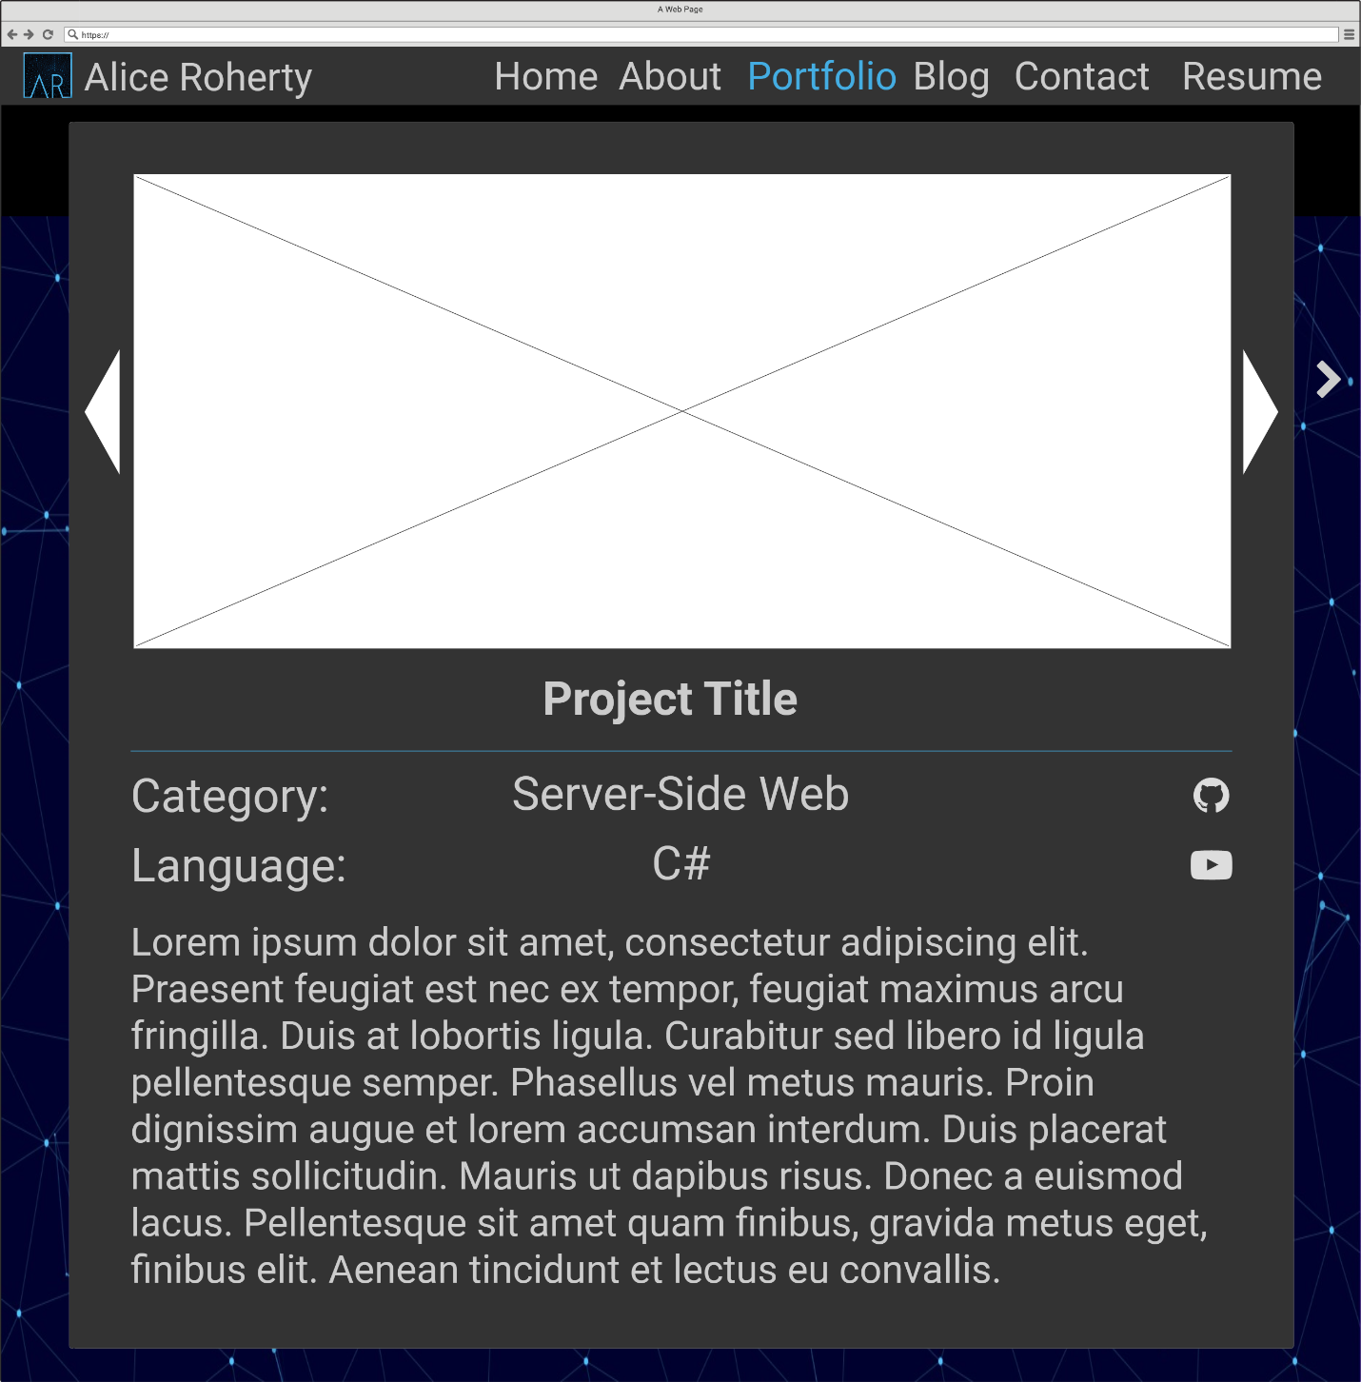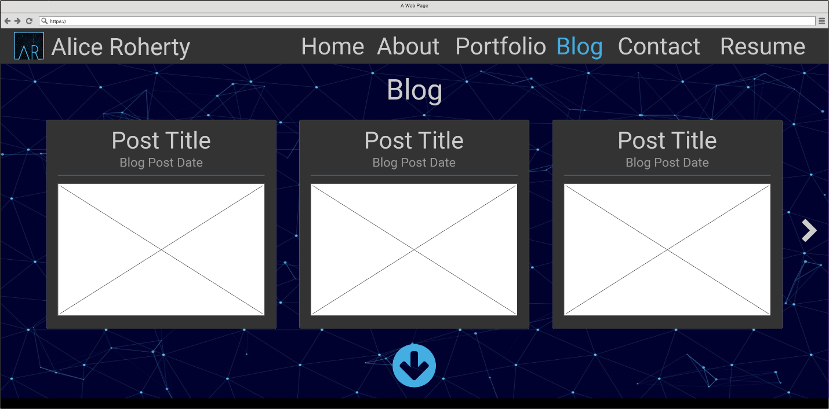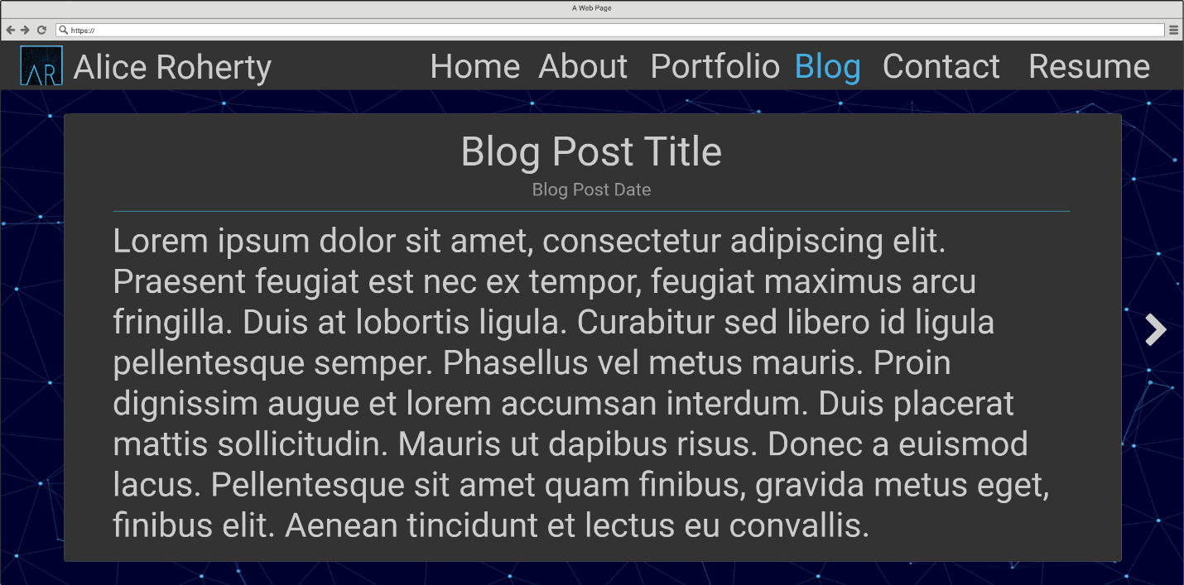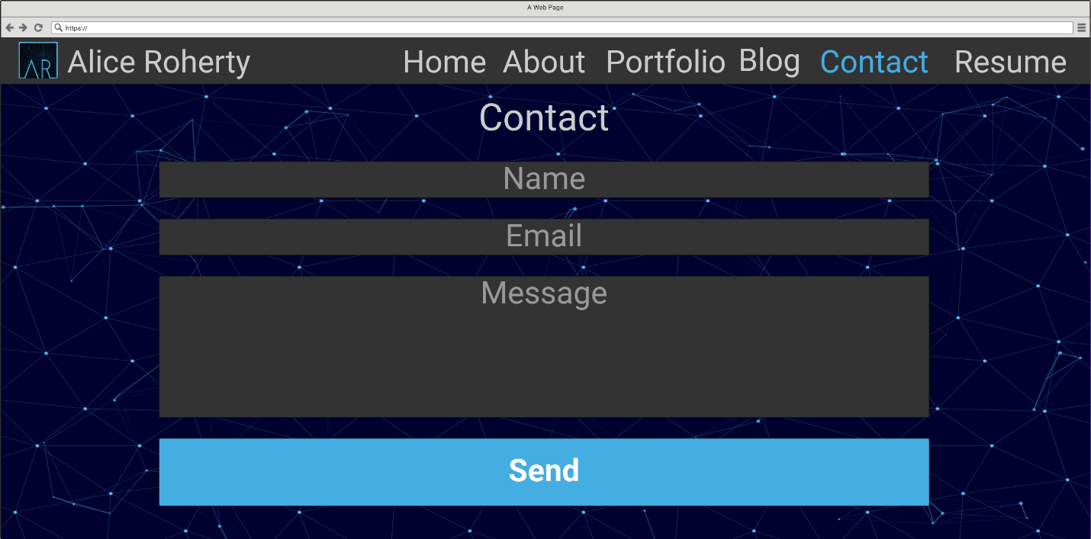

Sitemap:

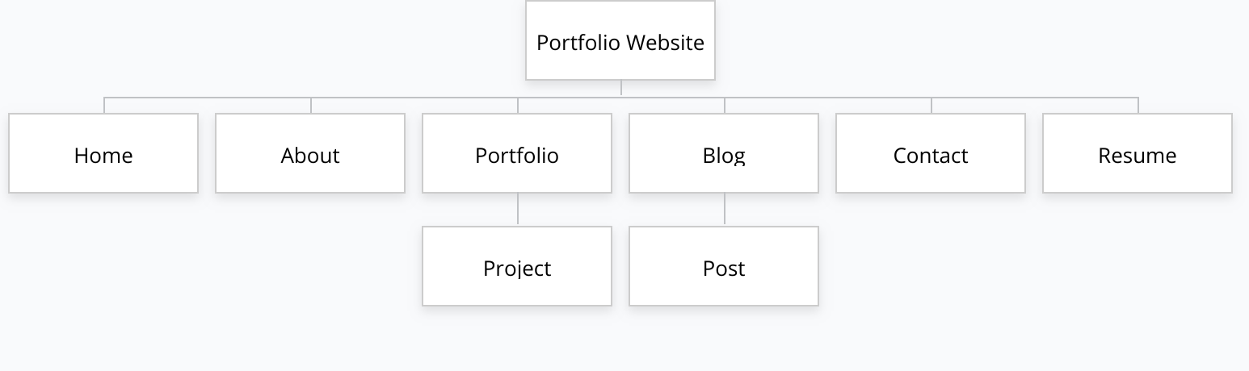

Color Scheme:

I intend to have an overall dark color scheme for my website, mostly consisting of blacks or dark greys. I also want to use #44ADE2 (light blue) as an accent color for my website as it will match my logo. For the text on my website I intend to use white and/or light grey colors.

Logo:



Use of Bootstrap:

I intend to use Bootstrap to speed up the process of styling webpages. Bootstrap will also likely be used to create my navbar.

Business Card:

